|  |  |
| --- | --- |
| **SUBJECT** | PMS – PROJECT MANAGEMENT SYSTEM |
| **RECORDER (Name Designation)** | Chalani Maduwanthi / Assistant Manager System Admin |
| **APPROVED BY (Name Designation)** |  |
| **CREATED DATE** | 03/08/2016 |
| **NO. OF PAGES INCLUDING THIS PAGE** |  |
|  |  |

Content

**PMS Introduction**

1. Create Credentials
   1. Create Credentials – Designation
   2. Employee details
   3. System User
2. Project Creation
   1. Create project or Edit project
   2. Create Task

**Workflow introduction**

1. Workflow
   1. Assigned workflow
   2. Edit workflow
   3. Transfer Workflow
   4. Workflow email alert
2. Project wise status and PMS user level view

**PMS – PROJECT MANAGEMENT SYSTEM**

**Projects**

PMS is designed (tailor-made) for our organization for the purpose of monitoring the performance of each employee even remotely.

Each employee is emphasized and guided on PMS and is expected to fulfill the PMS requirements on time in a regular basis.

Each one- time task assigned for an employee is a Project for him/her. Therefore, PMS should be created with the specific tasks and deadlines for each.

PMs Creation needs to be sent to System Admin Department (since PMS creation is possible only for those who have admin rights in the PMS in System Admin Department). Updating and amendments for the same PMSs should be followed through by the relevant PMS user (it should not be sent for System Admin Department)

1. **Create Credentials**

For New Recruitments, HR will raise an IT ticket (service request system) to IT support with access requirement form. Then once you system admin receive that ticket through mail and HOD check and download the access request form from “Specie work” (TEKNOWLEDGE SHARED SERVICE HELPDESK).Based on the form will create PMS credentials and send to employee office email address and update the IT ticketing system as well to confirm the work has done.

* 1. Create Credentials – Designation

Check the designation whether that designation already in access or if not need to create a designation in the system.

PMS – Designation Details – Search (type the designation and if the designation is available in the system it will appear)

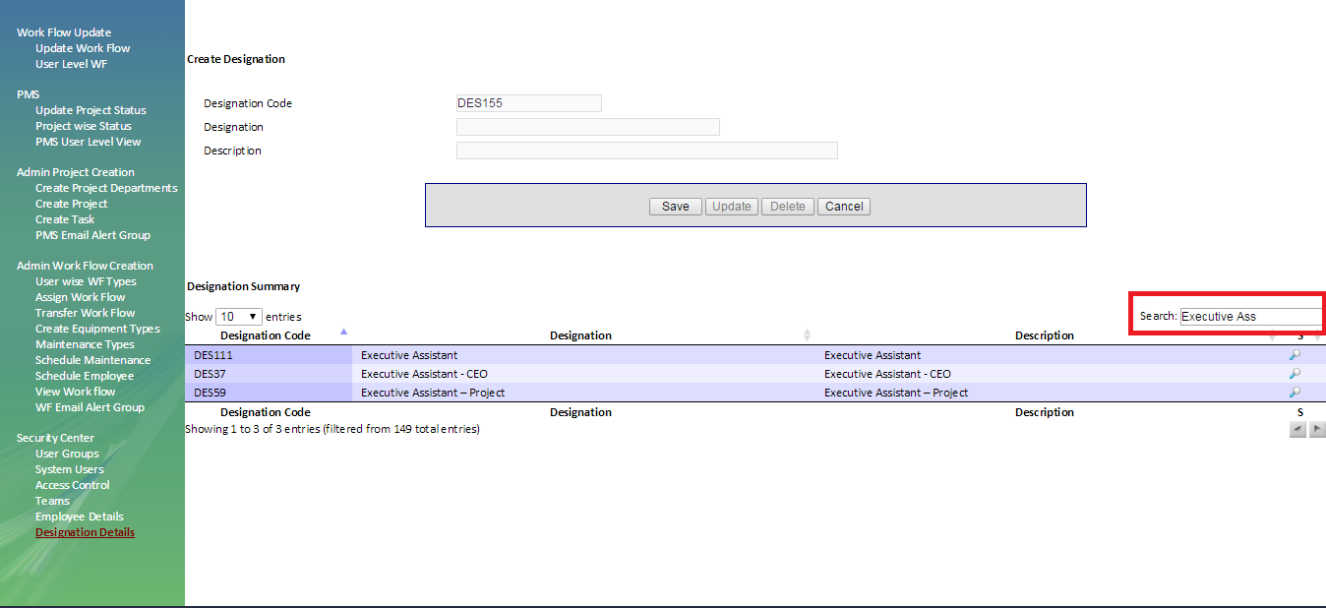If the designation is not available in the system need to create a designation

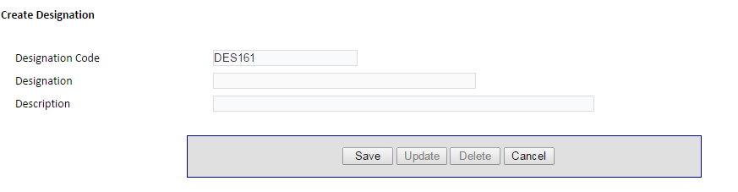

Type the designation that need to be added and “**save**”.

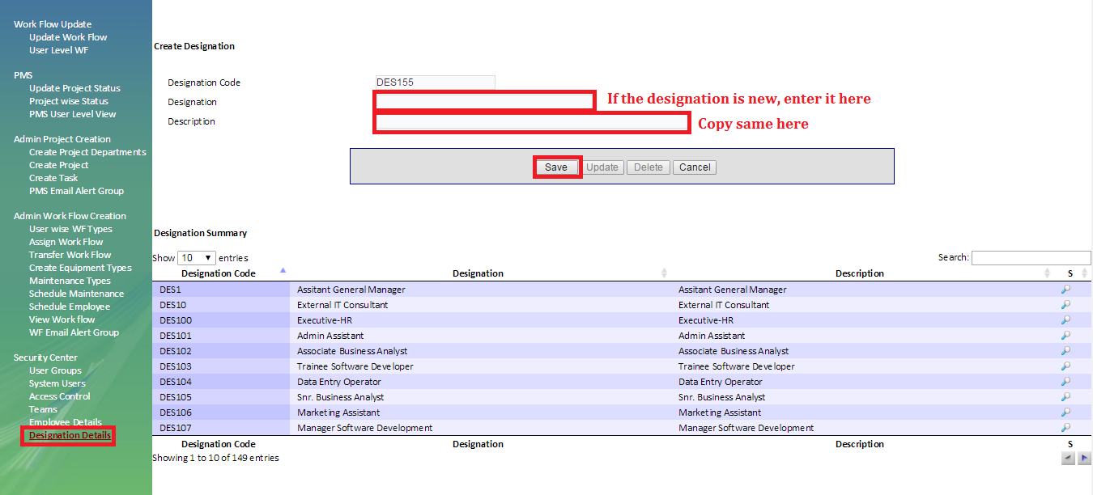If we need to change the designation search and select the designation and click “ ” and once you done the changes click “**update**”

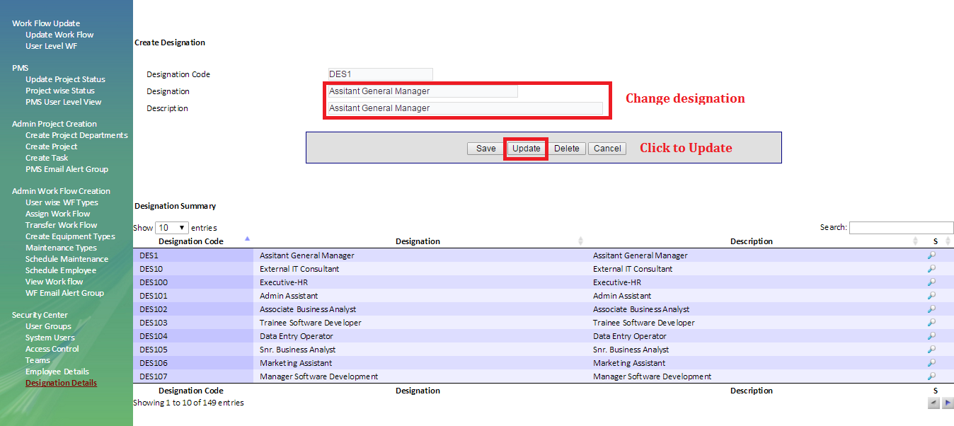

* 1. Employee details -

Add a new employee

Once you have done the designation need to enter employee details to the system. To add the employee, click on  symbol refresh the page and enter details as below,

Search designation – Type the country as system mentioned (SL/US/UK/MLD/TL) – title – first name - Last name – email address – click “ **Save** “

Please note Highlighted areas are compulsory to fill.

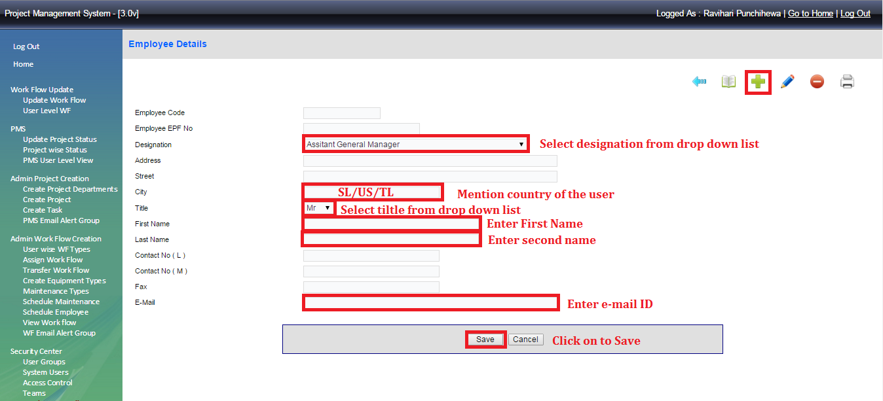Edit existing Employee

Click the symbol then search the employee and click  which is place before the name.

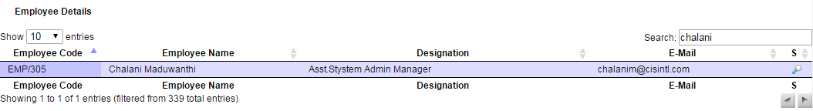

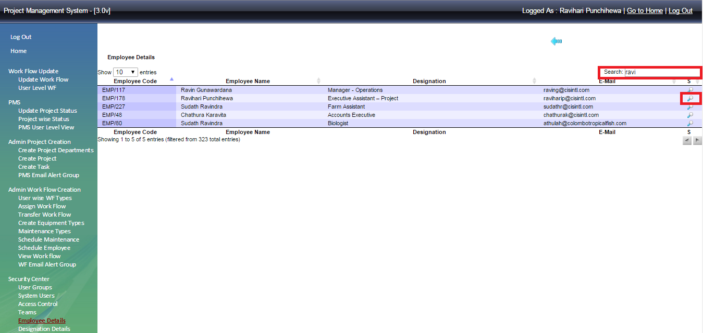

* 1. System User -

Create Access for new employee

Creating an access account as requested in the access requesting form (User / Admin) to the new employee. Refresh the page by clicking  and add details as below,

User Name ( Ex: chalanim ) – employee details search from the drop down list – set the pass work and re type it – set Expr in days as “0”(Zero) – User level as requested ( select Manage for User level access and Administrator for Admin access)

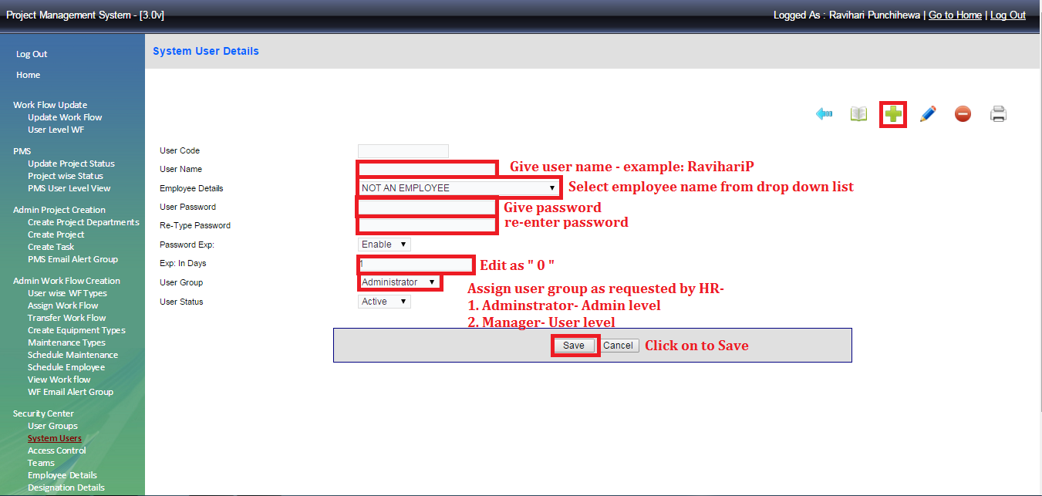

Edit Access in existing employee

Search current user  - type existing user name – click  in front of the name.



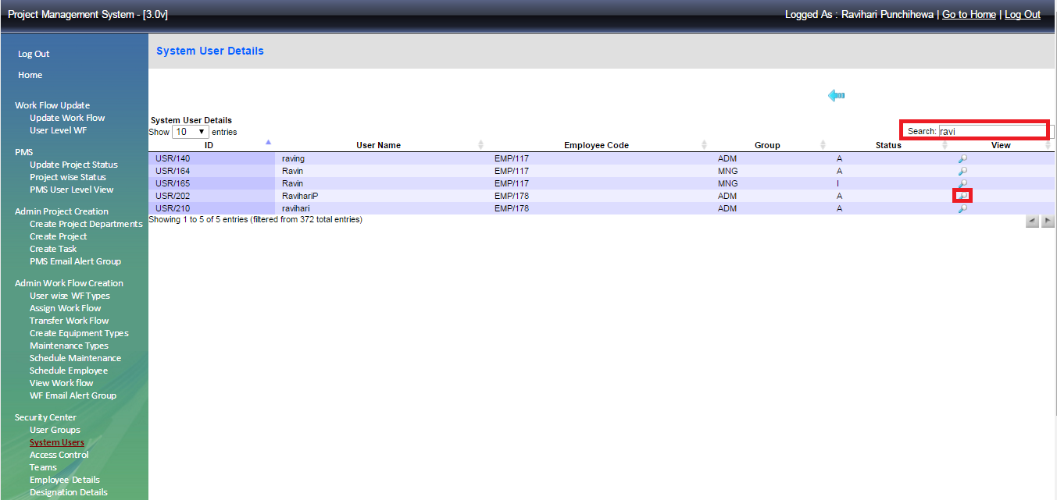

Click  to edit user name or password

Re type the user name and password - make “0” Zero Expr days – select user group as administrator or manager – “**Save**”

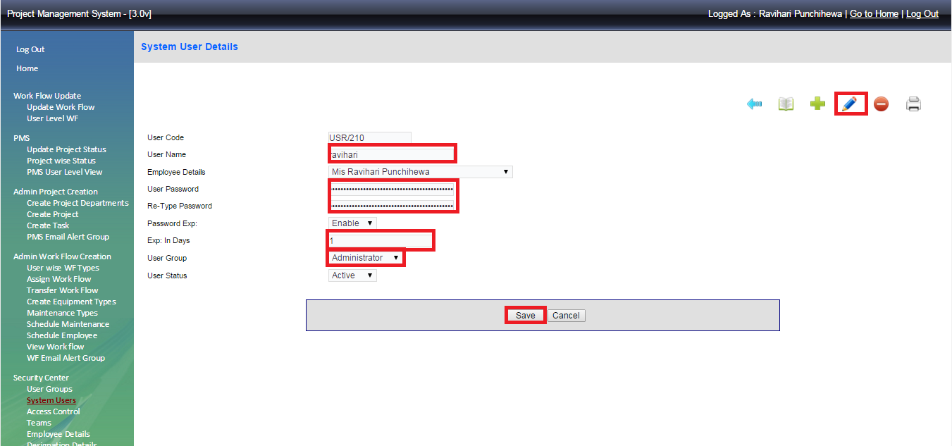

1. **Project Creation**

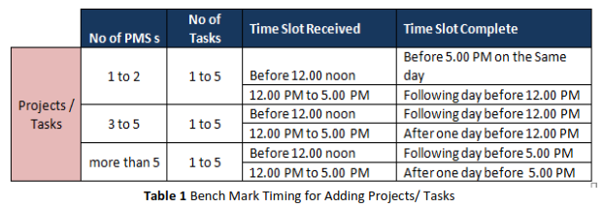

Bench mark times for PMS creations with more than 5 tasks will have to be handled case by case. Soon after a new PMS is added / existing PMS is updated/ extended, screenshots will be sent via email to relevant person who re3quested the requirement to confirm the request is done.

Once3 a PMS is created for an employee, any changes, updates or extensions required should be sent to System admin Department. Through the relevant HOD without the relevant HOD’s approval, none will be performed. The same requirement in respect of HODs will be performed ONLY with the approval from CEO.

2.1 Create project or Edit project

Select “**Create Project**” to add new project or to edit project details.

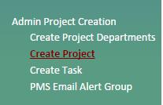

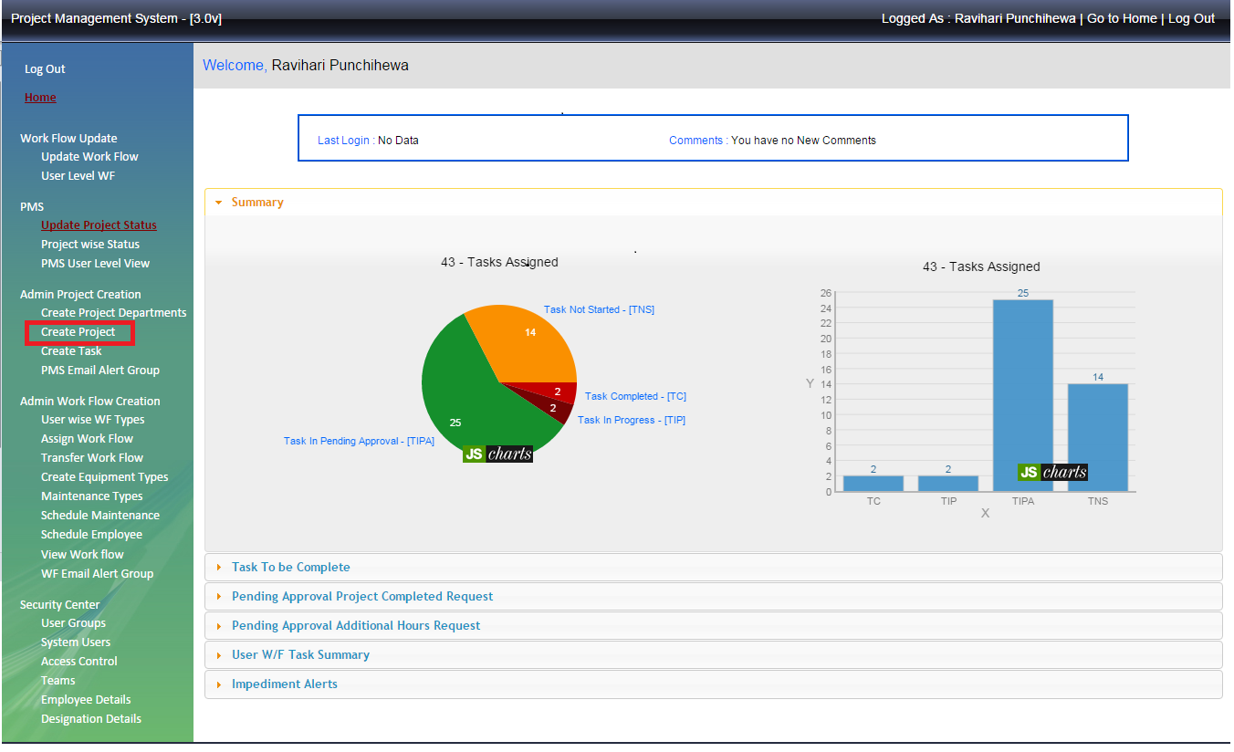To add a new project click  symbol and fill the requested details

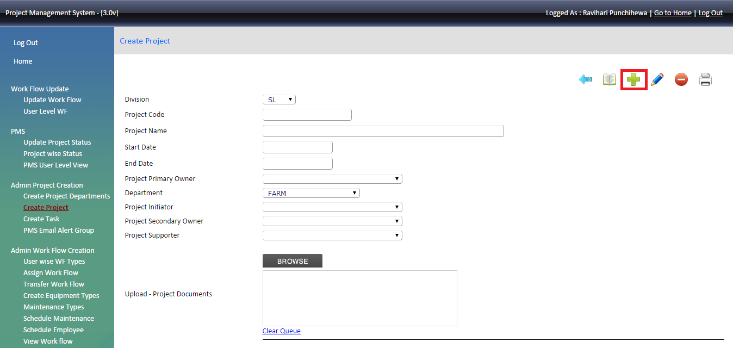

Division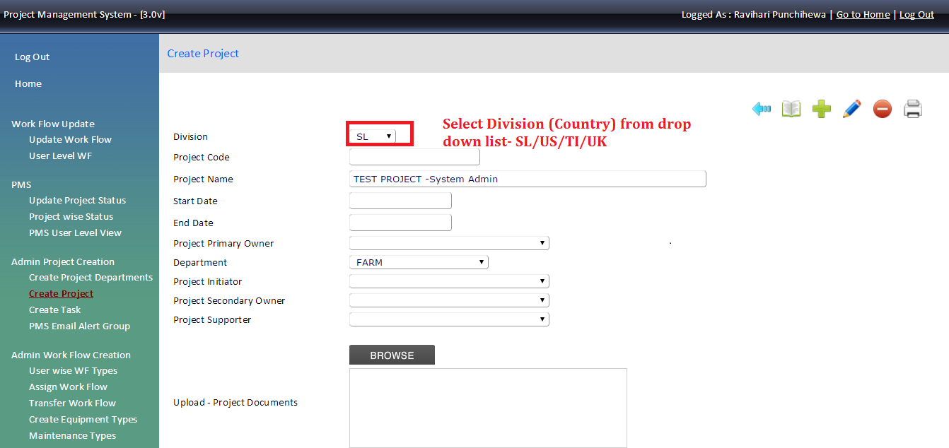Project code – once we save the project details, project code will generate automatically.

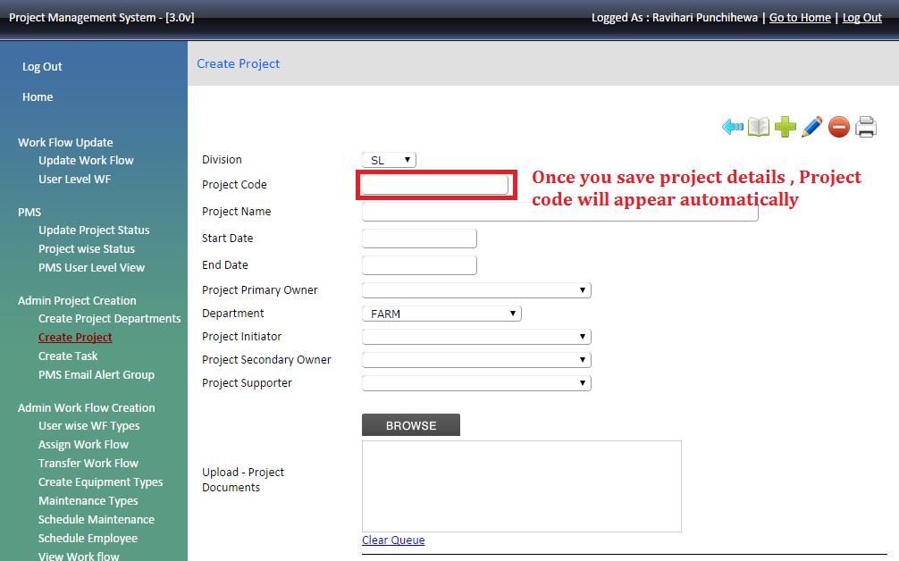

Project Name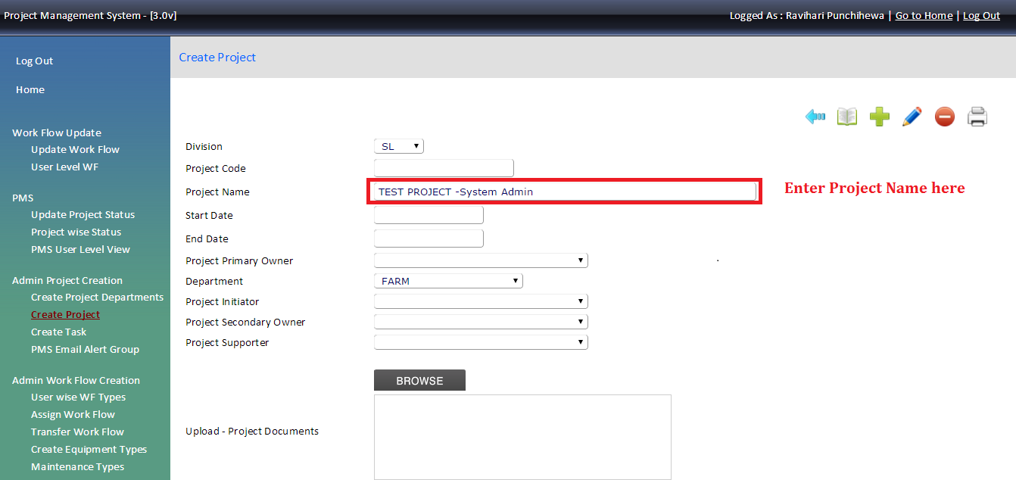

Start date & End date 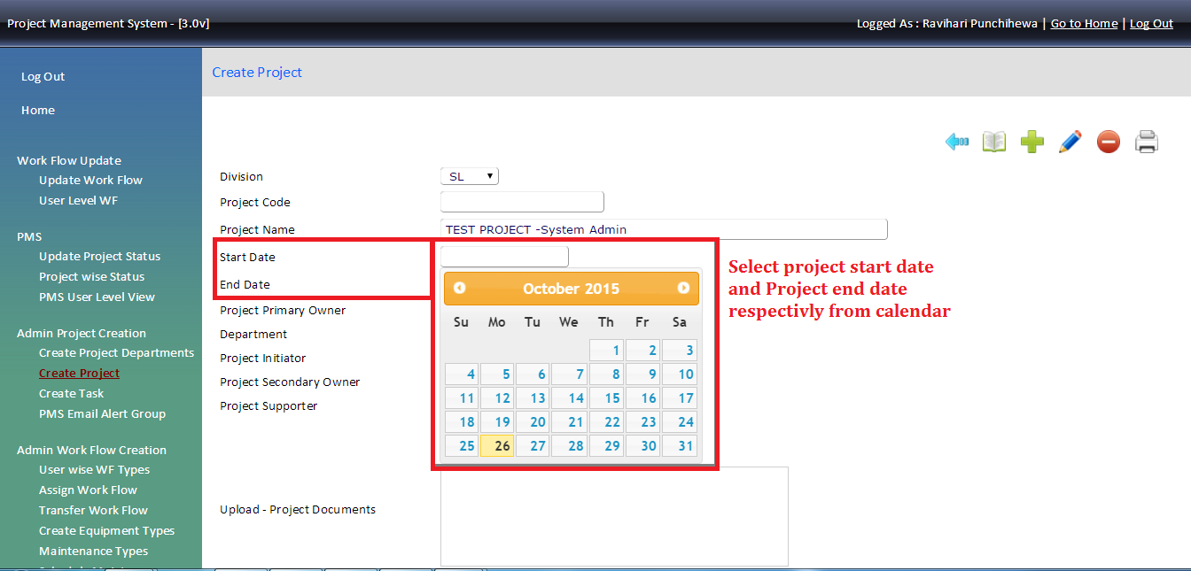Project Primary owner 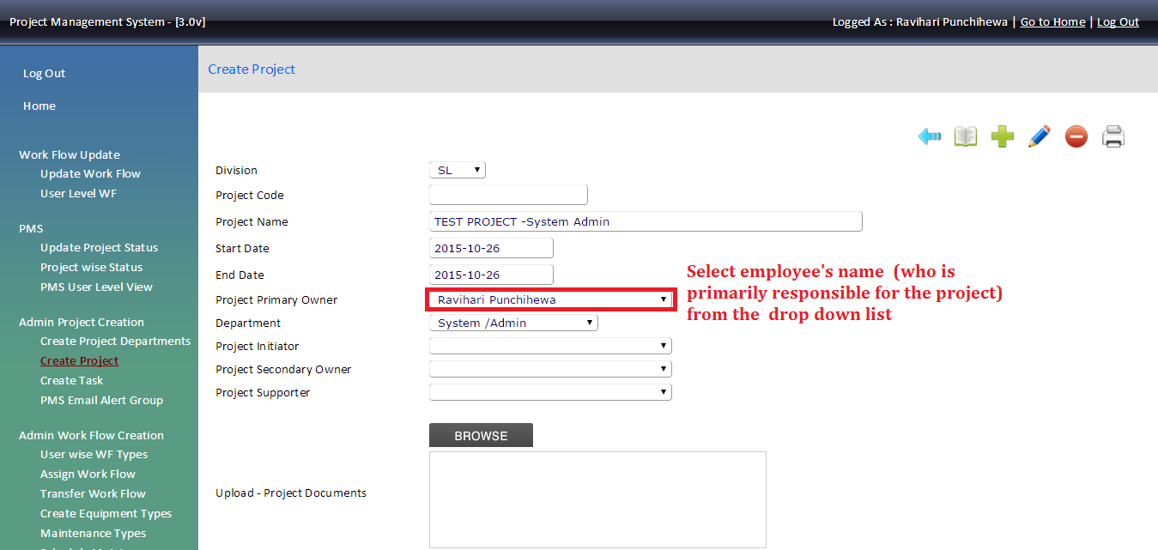select the department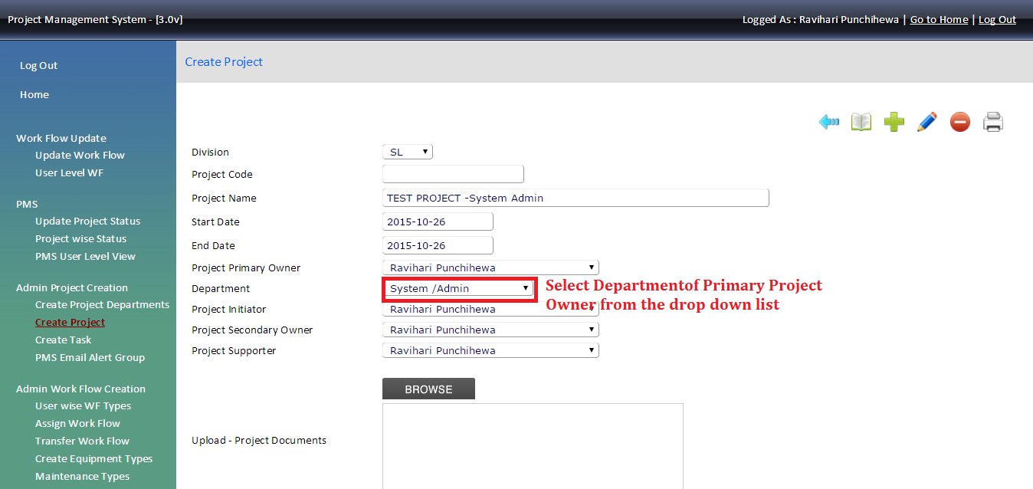

Project initiator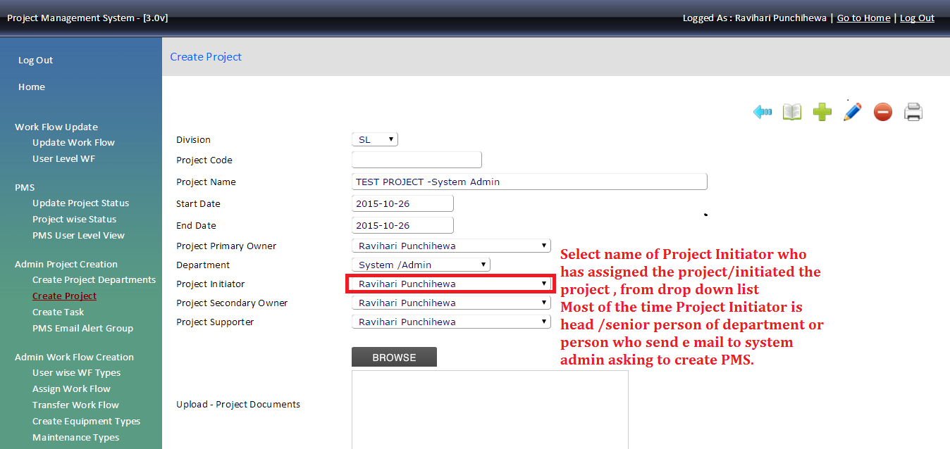 Project secondary owner (if applicable otherwise select “none”)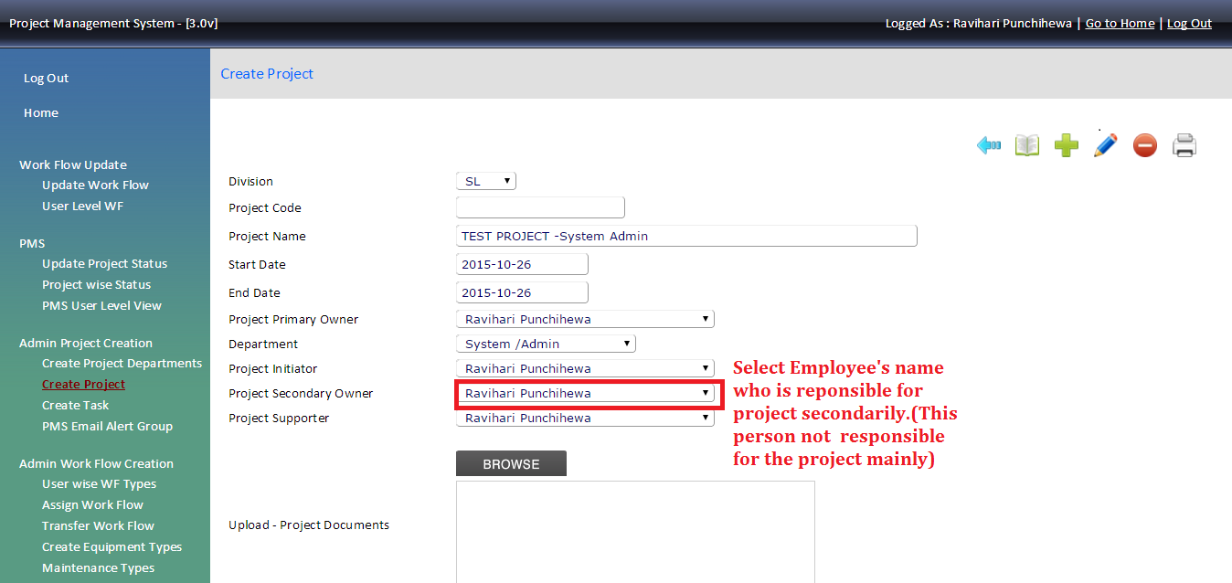Project supporter ( if applicable otherwise select” none”)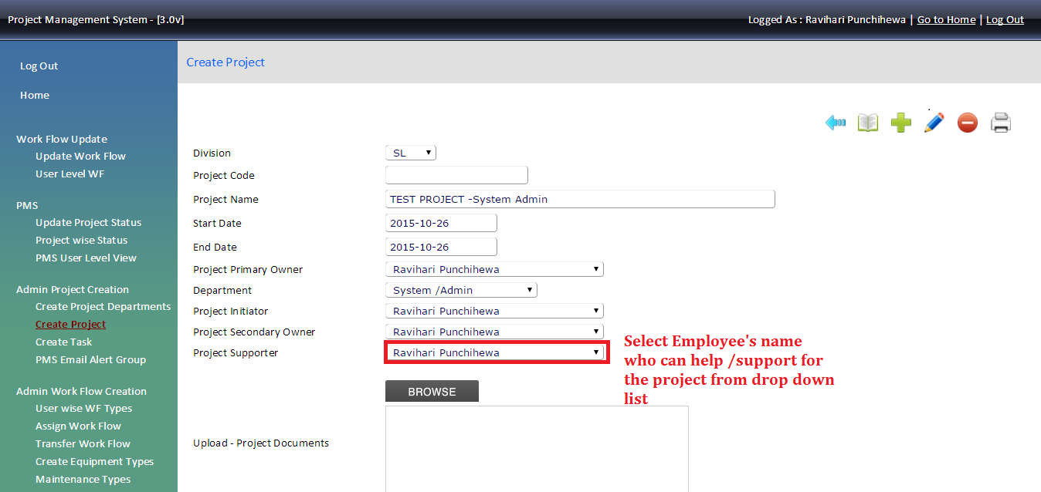

Browse the document if you need to attached any document to the project

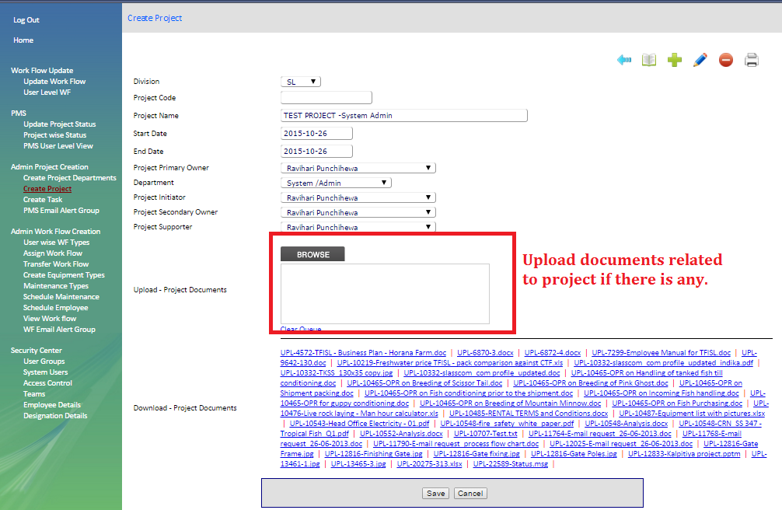

Click “**Save”** to save the create project in the system.

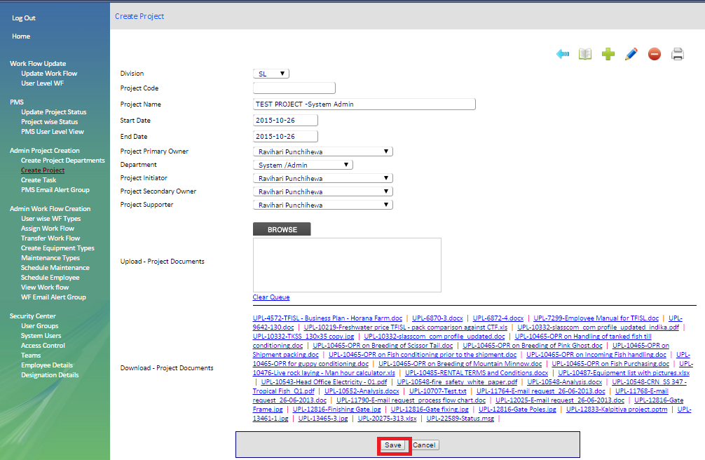

Edit Project

To edit existing project click  symbol in create project page and search the project given by name or by project code.

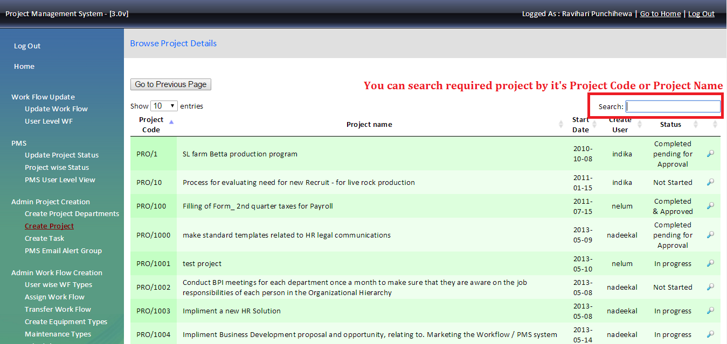

Once you found the project that you need to edit click  in front of the project name then for edit. Once the screen appear edit details (as we create a project) and “Save”.

2.2 Create Task

Create project tasks under created project. If we don’t have the task and only the project we need to take the same topic of the project and create a task under that project without not creating a task (to create a task under project is compulsory).

Note: - Necessary to create at least one task for each project otherwise user cannot see the any of assigned project in their home page.

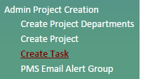

Search project  by name or by project code then click the  in front of the name

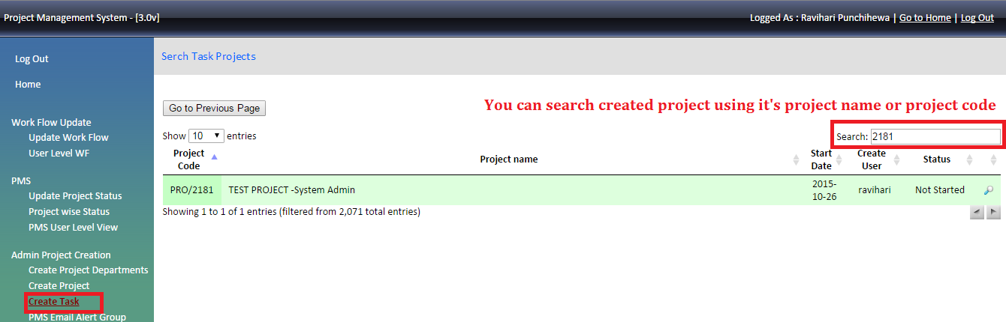

Create Task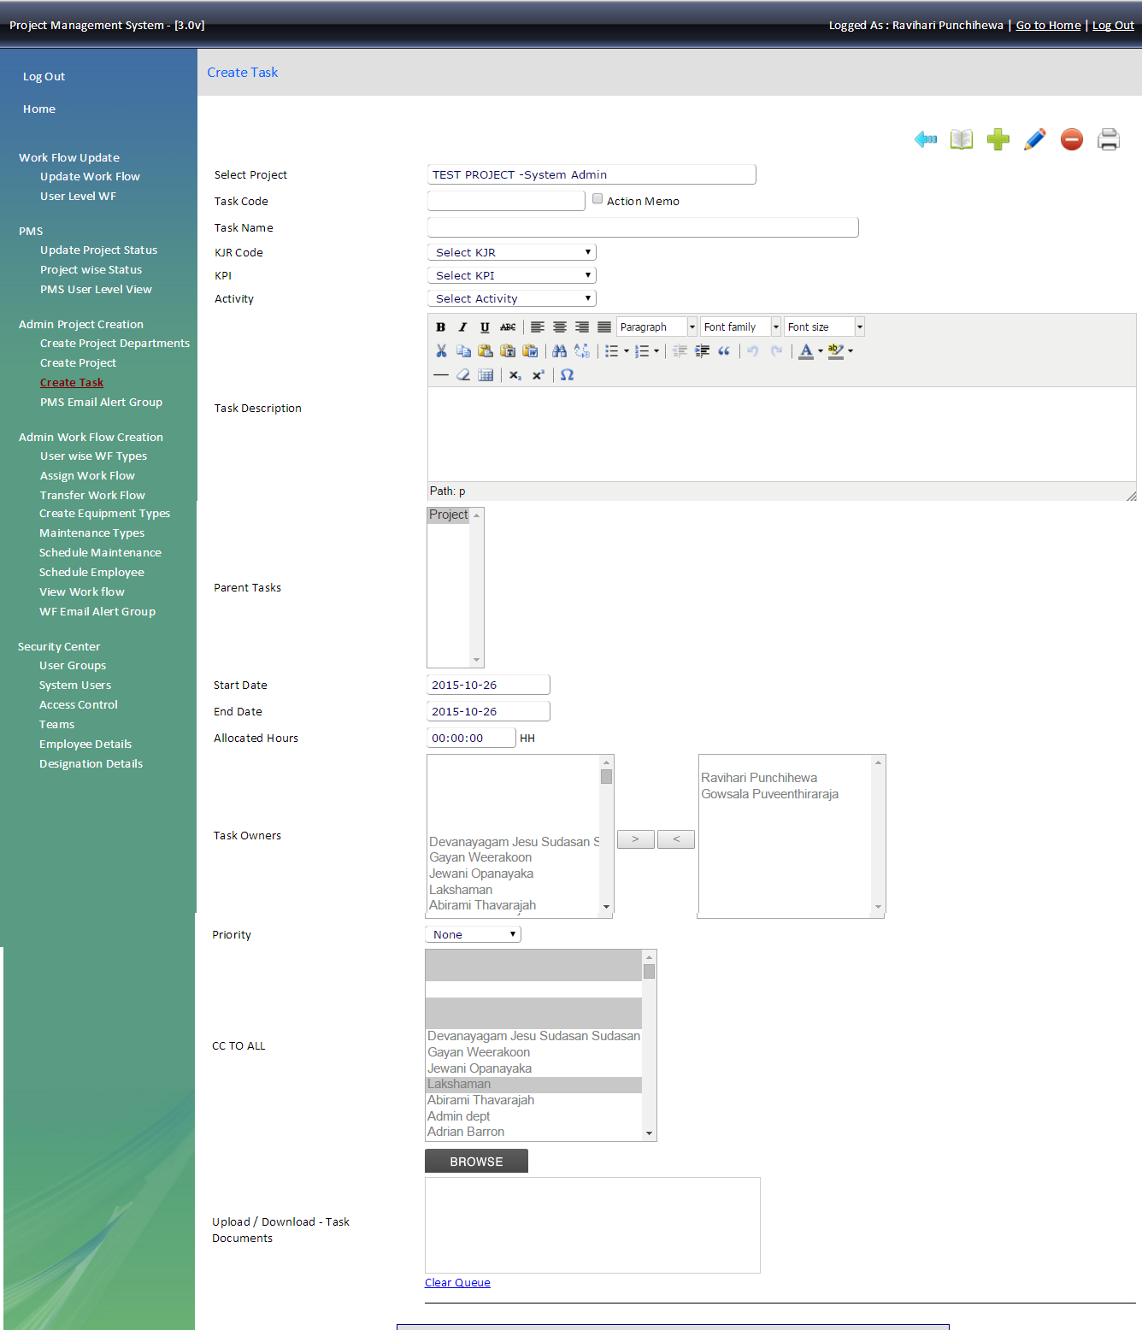

Click the  to refresh the page and add details as follows.

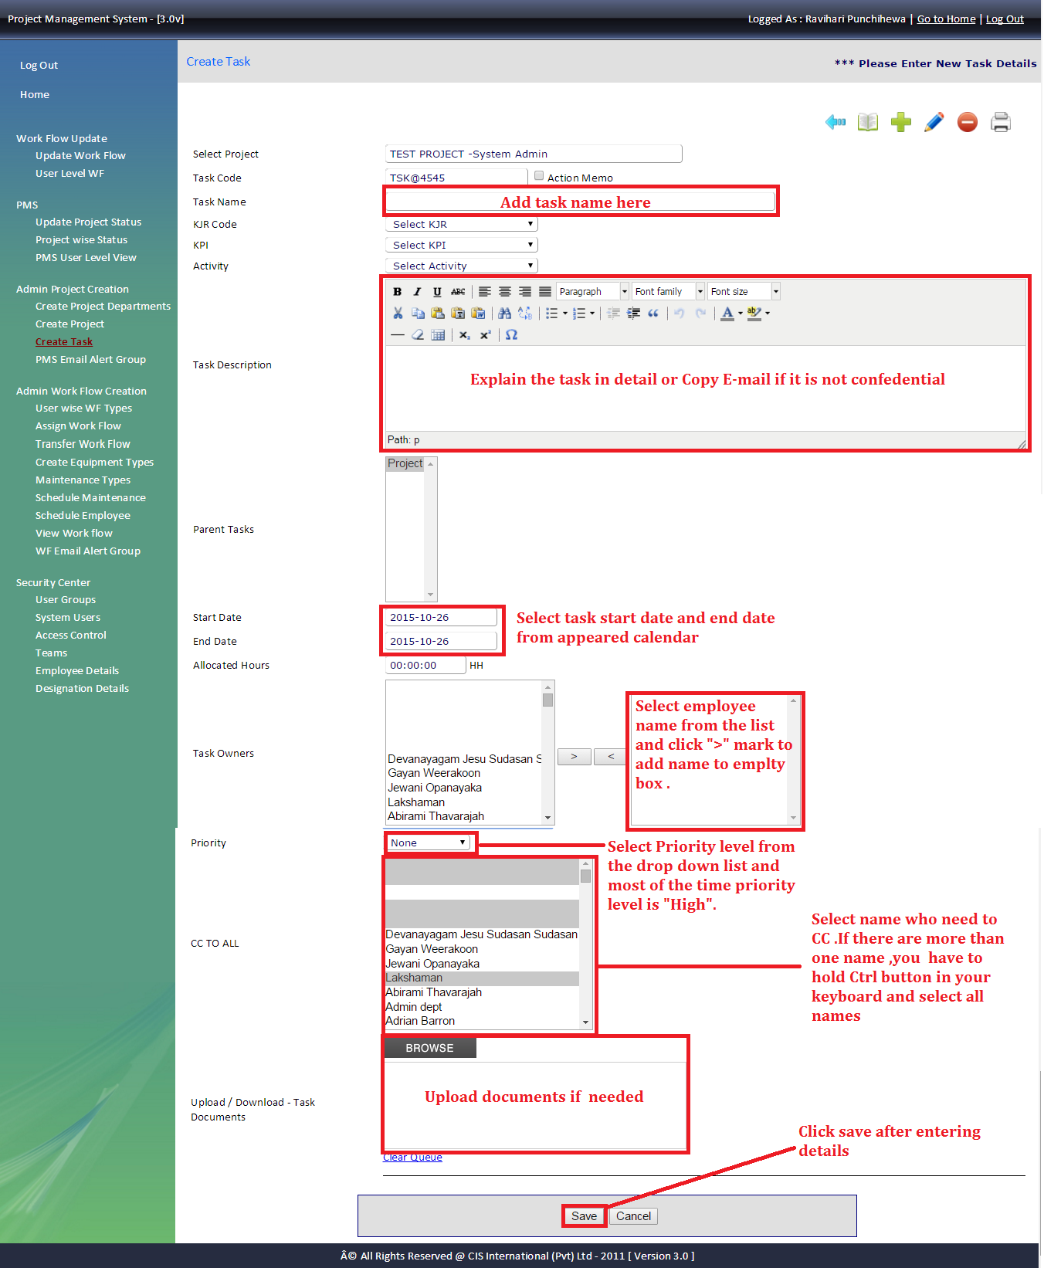

To add more task to the same project add by clicking  and enter tasks.

To edit tasks details select the task from parent’s task and click  to edit or change details.

To delete the task , select the task from parent’s task and click  and save changes.

Once created the project send email with the attached created screen shot of the project

Note: Extend the project end date once you extend the project task and vice verse.

1. **Workflow**

Workflow

Workflow is a collection of tasks that each employee performs on daily basis. HOD of each department is responsible for issuing workflows for their staff members. In general workflows are available only from Monday to Friday (if not exceptional). Each day is covered with list of task to be performed during the day with an allocated time slot. Collection of allocated time slots for each day should be a total of 8 hours or more.

Workflow tasks could be repetitive for two or more days. Also there are tasks daily as well as only for specific days. End of each day, employee should refer his /her workflow and update it accordingly.

Summary of all updates / dues are sent via email to relevant staff member, System Admin Department and the relevant HOD.

* 1. Assigned workflow

This tool is to create or edit workflow of the employee.

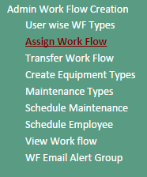

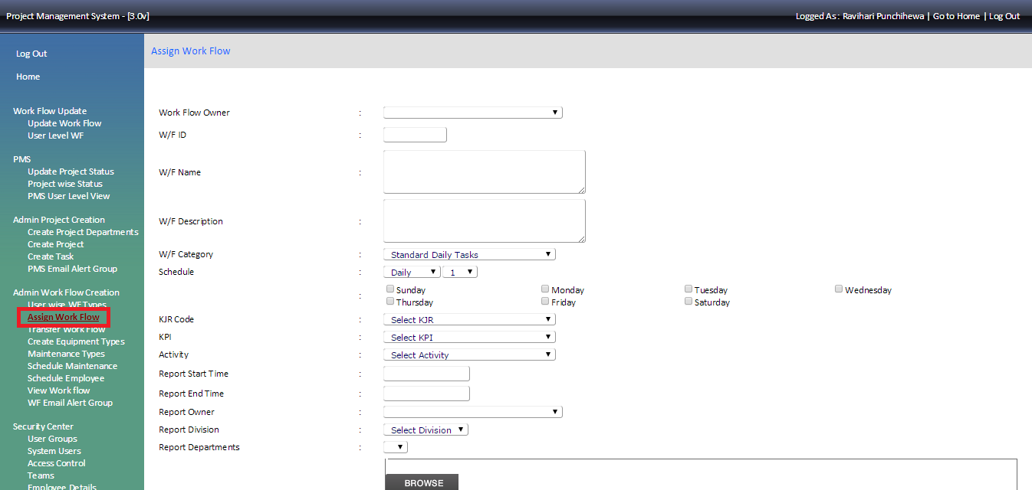

Select the name in the work flow owner and select New at the bottom to refresh the page.

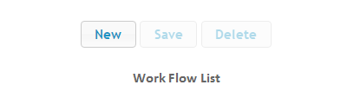

Enter details as mentioned as follows

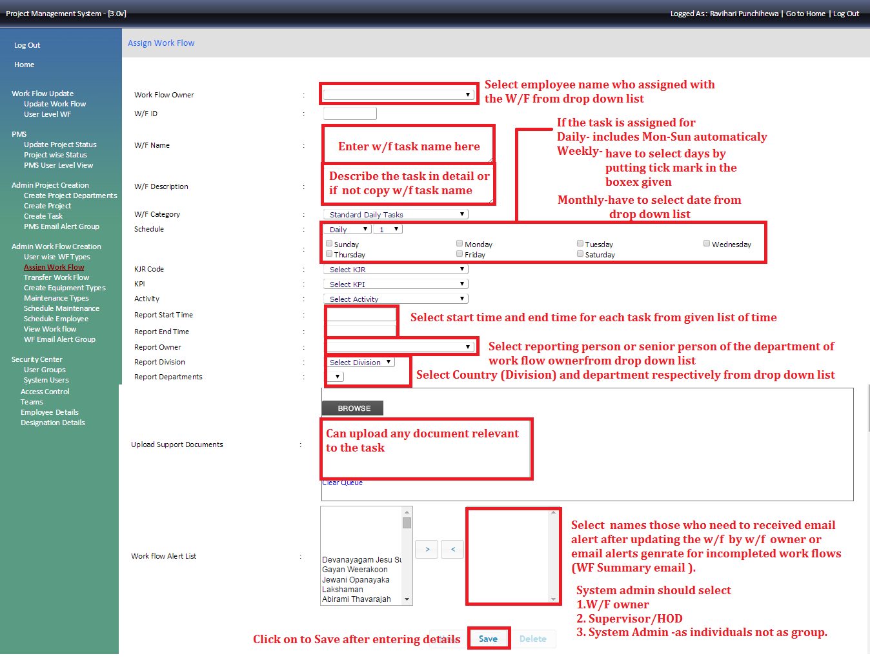

3.2 Edit workflow

To edit workflow task – go to task list and select the task and click edit

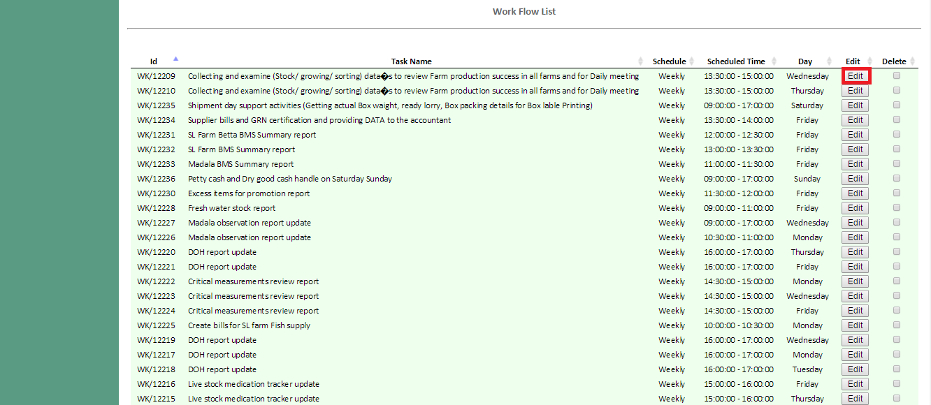

Then once the following screen will appear and then update details and click update button to save edit details

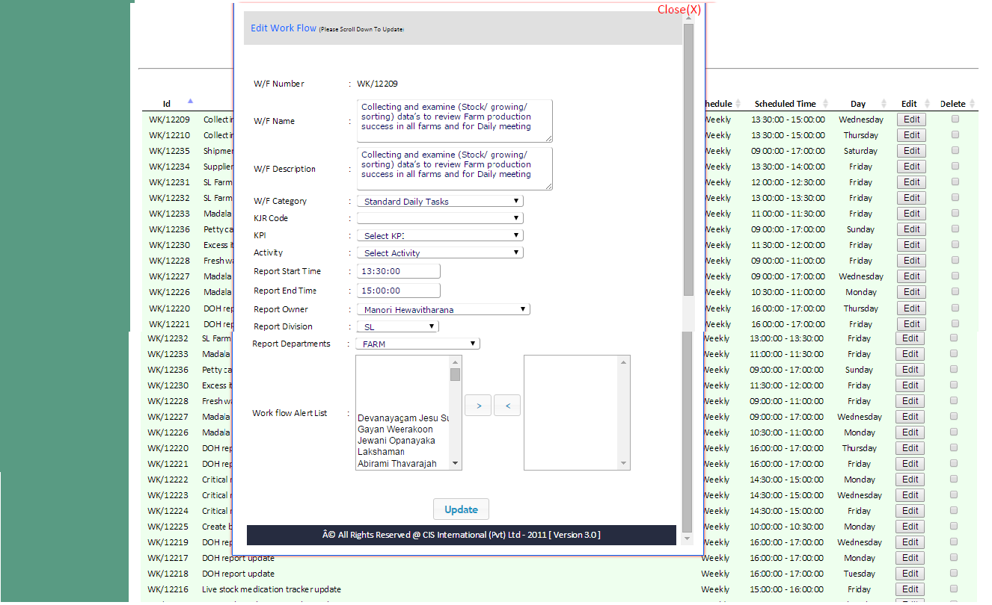

Please note need to change each task that you need to edit as above.

If one workflow task is for five days (Mon to Fri) you need edit each task (5 tasks for 5 days) and edit the same way.

To delete task from Work Flow you have to put “🗸” on to the tick box and click on to delete button.

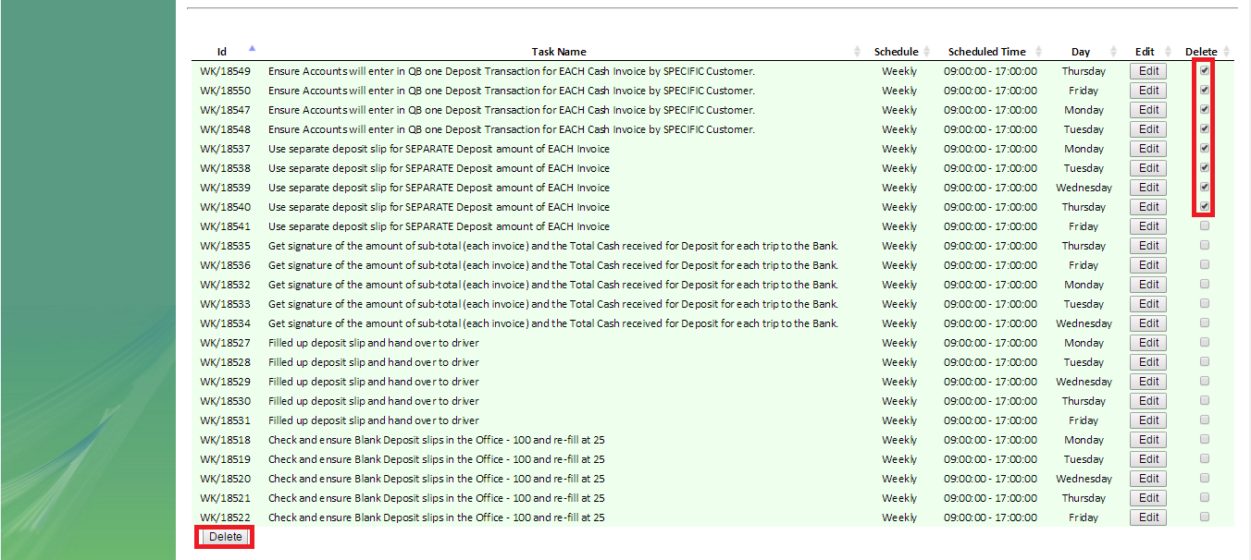

3.3 Transfer Workflow

Go to the transfer workflow section and follow the mentioned instructions as in the screen shot

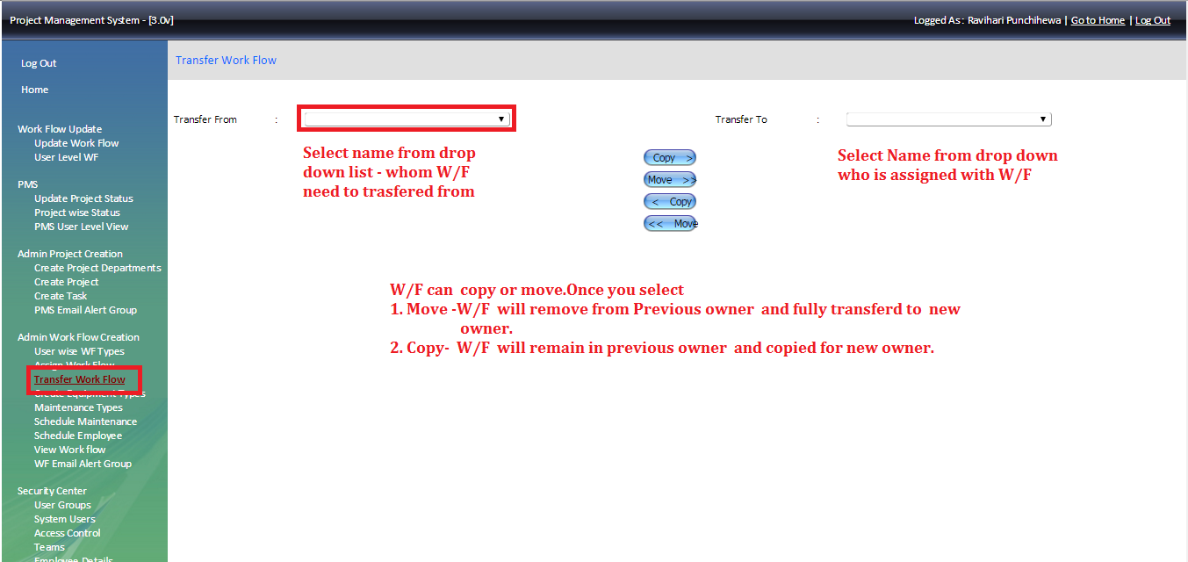

3.4 Workflow email alert

If there is requirement for any senior person to received work flow after entering it to the system, you can use this section to add those recipients.

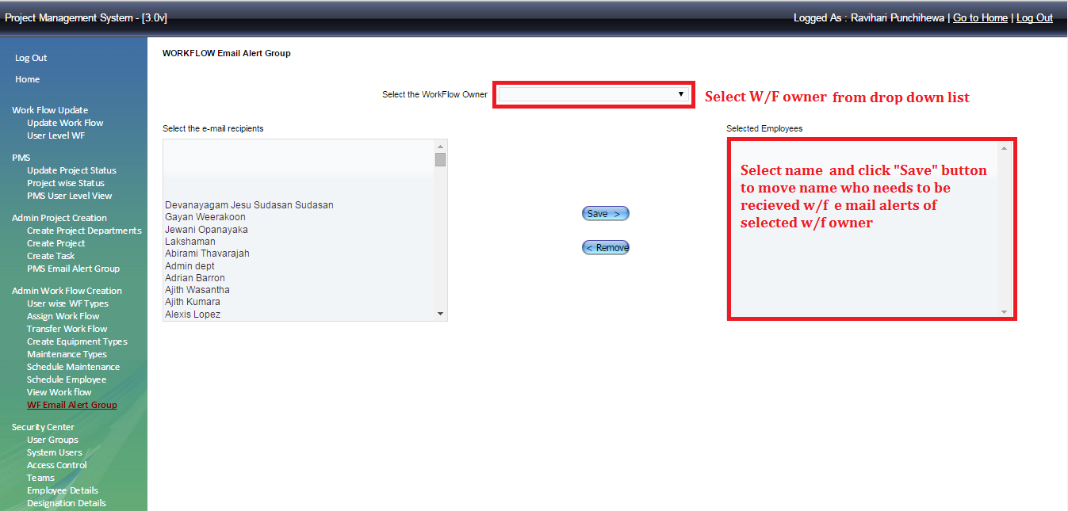

To get the workflow summary – Create project department and select the department then add the head of the department (who wants to have the department summary) with system admin

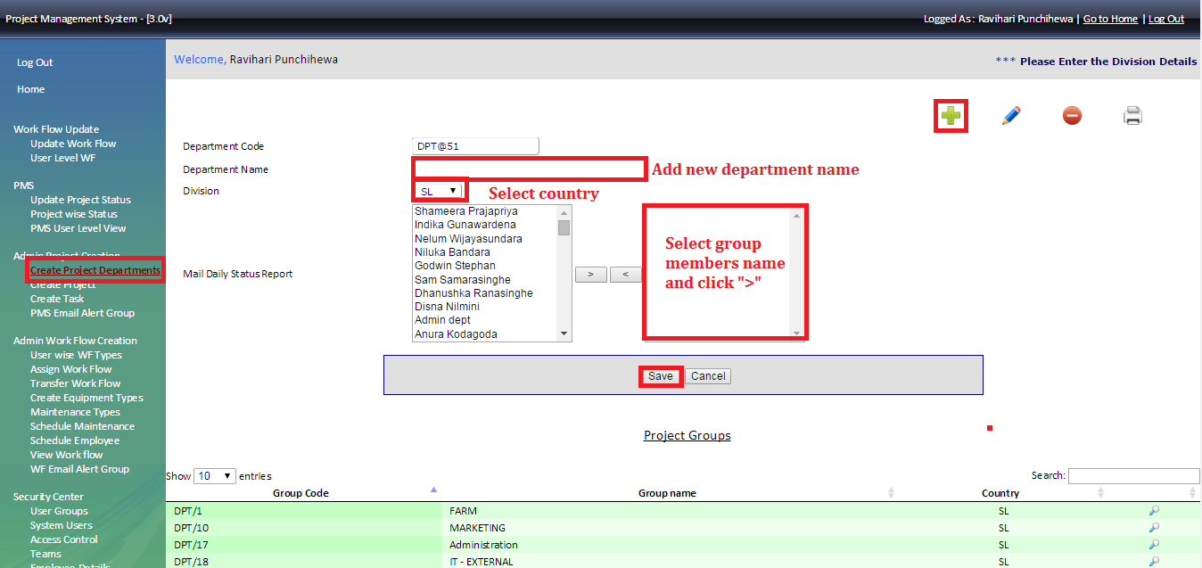

1. **Project wise status and PMS user level view**

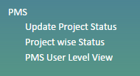

Primary responsibility of System Admin is to follow up and conduct PMS review meetings for each department.

Using “Project Wise Status “section system admin can have a report in various categories as below

1. All projects
2. SL projects/US Projects
3. SL department wise projects /US department wise projects
4. Project owner wise report
5. Task owner wise report
6. Projects in specific time period

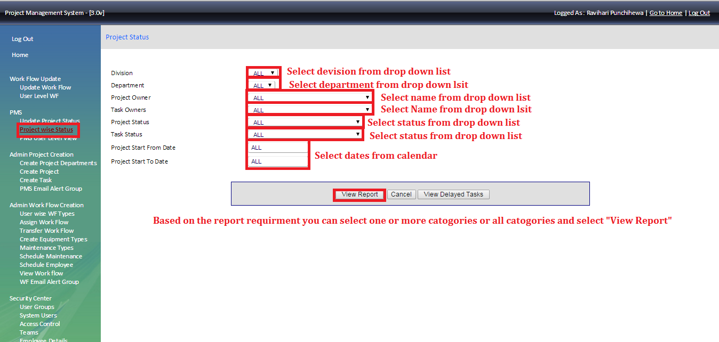Also system admin can have user wise report using “PMS user level view”

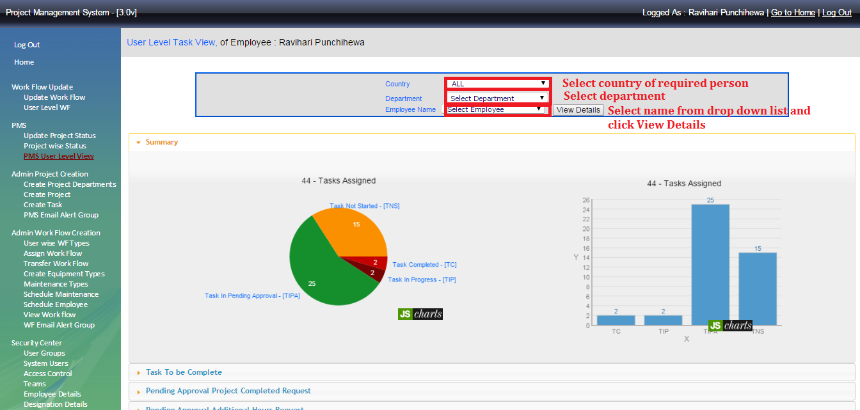

Pie chart gives overall idea about projects assigned to selected employee.

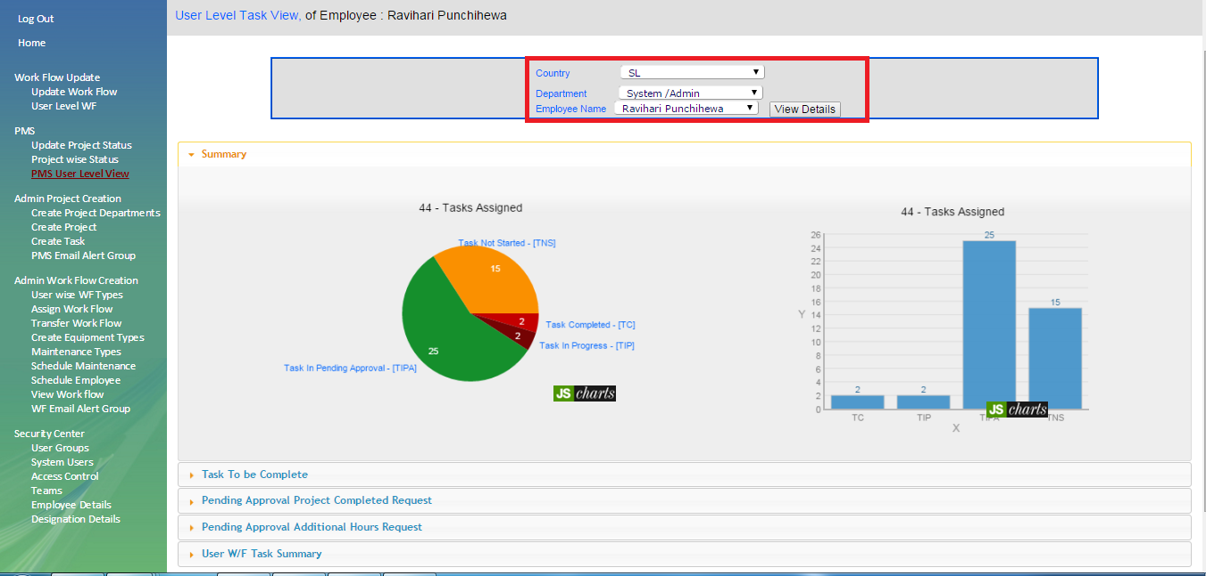

To view more details, click on to “to be complete” as below screen shot.

